WEEK 1

Exercise 1: Singleton Pattern

public class SingletonPatternDemo {

static class Logger {

private static Logger *instance*;

private Logger() {

System.*out*.println("Logger instance created");

}

public static Logger getInstance() {

if (*instance* == null) {

*instance* = new Logger();

}

return *instance*;

}

public void log(String message) {

System.*out*.println("LOG: " + message);

}

}

public static void main(String[] args) {

Logger logger1 = Logger.*getInstance*();

logger1.log("Starting the application");

Logger logger2 = Logger.*getInstance*();

logger2.log("Continuing the application");

if (logger1 == logger2) {

System.*out*.println("Both logger instances are the same (Singleton Verified)");

} else {

System.*out*.println("Different instances");

}

}

}

OUTPUT

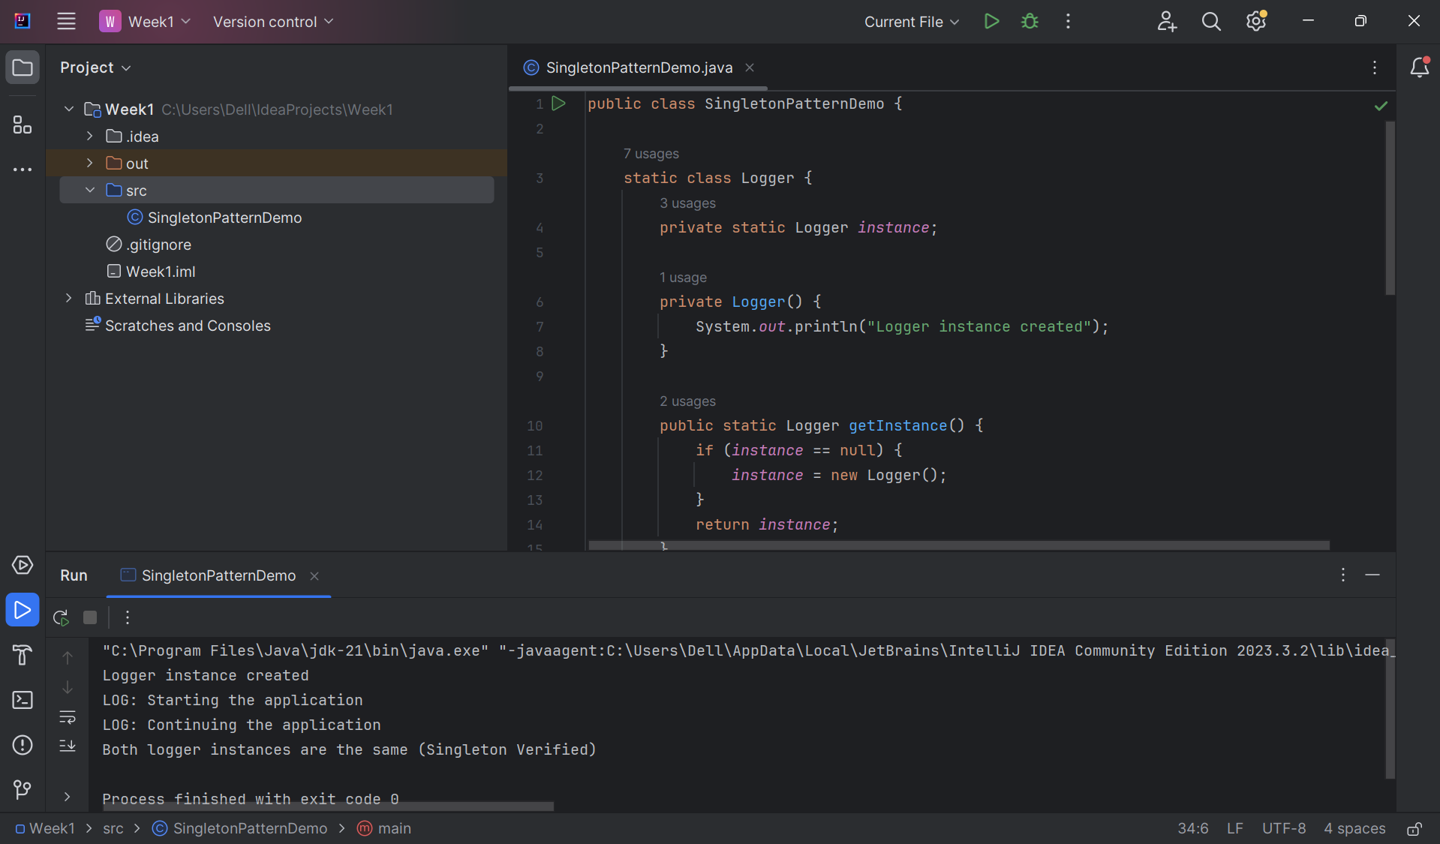

Exercise 2: E-commerce Platform Search Function

import java.util.\*;

class Product {

int productId;

String productName;

String category;

Product(int productId, String productName, String category) {

this.productId = productId;

this.productName = productName;

this.category = category;

}

}

class LinearSearch {

static int search(Product[] products, String key) {

for (int i = 0; i < products.length; i++) {

if (products[i].productName.equalsIgnoreCase(key)) {

return i;

}

}

return -1;

}

}

class BinarySearch {

static int search(Product[] products, String key) {

Arrays.*sort*(products, Comparator.*comparing*(p -> p.productName));

int left = 0, right = products.length - 1;

while (left <= right) {

int mid = (left + right) / 2;

int comp = products[mid].productName.compareToIgnoreCase(key);

if (comp == 0)

return mid;

else if (comp < 0)

left = mid + 1;

else

right = mid - 1;

}

return -1;

}

}

public class EcommerceSearchFunction {

public static void main(String[] args) {

Product[] products = {

new Product(101, "Laptop", "Electronics"),

new Product(102, "Phone", "Electronics"),

new Product(103, "Shoes", "Fashion"),

new Product(104, "Book", "Stationery")

};

int index1 = LinearSearch.*search*(products, "Phone");

System.*out*.println("Linear Search found at index: " + index1);

int index2 = BinarySearch.*search*(products, "Phone");

System.*out*.println("Binary Search found at index: " + index2);

}

}

OUTPUT

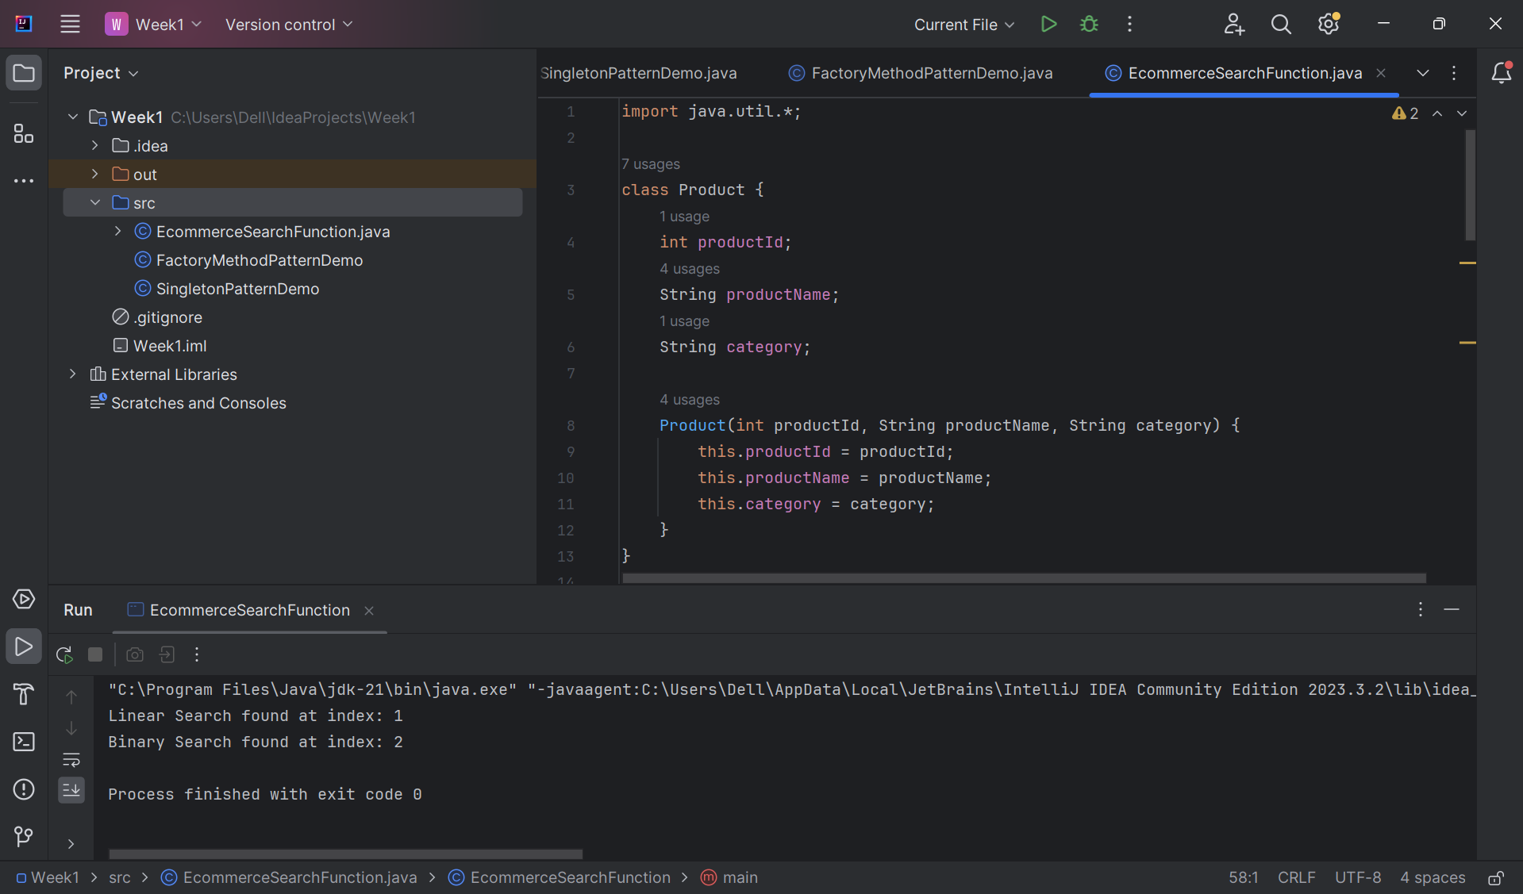

Exercise 2: Implementing the Factory Method Pattern

public class FactoryMethodPatternDemo {

interface Document {

void open();

}

static class WordDocument implements Document {

public void open() {

System.*out*.println("Opening a Word Document");

}

}

static class PdfDocument implements Document {

public void open() {

System.*out*.println("Opening a PDF Document");

}

}

static class ExcelDocument implements Document {

public void open() {

System.*out*.println("Opening an Excel Document");

}

}

abstract static class DocumentFactory {

public abstract Document createDocument();

}

static class WordDocumentFactory extends DocumentFactory {

public Document createDocument() {

return new WordDocument();

}

}

static class PdfDocumentFactory extends DocumentFactory {

public Document createDocument() {

return new PdfDocument();

}

}

static class ExcelDocumentFactory extends DocumentFactory {

public Document createDocument() {

return new ExcelDocument();

}

}

public static void main(String[] args) {

DocumentFactory wordFactory = new WordDocumentFactory();

Document wordDoc = wordFactory.createDocument();

wordDoc.open();

DocumentFactory pdfFactory = new PdfDocumentFactory();

Document pdfDoc = pdfFactory.createDocument();

pdfDoc.open();

DocumentFactory excelFactory = new ExcelDocumentFactory();

Document excelDoc = excelFactory.createDocument();

excelDoc.open();

}

}

OUTPUT

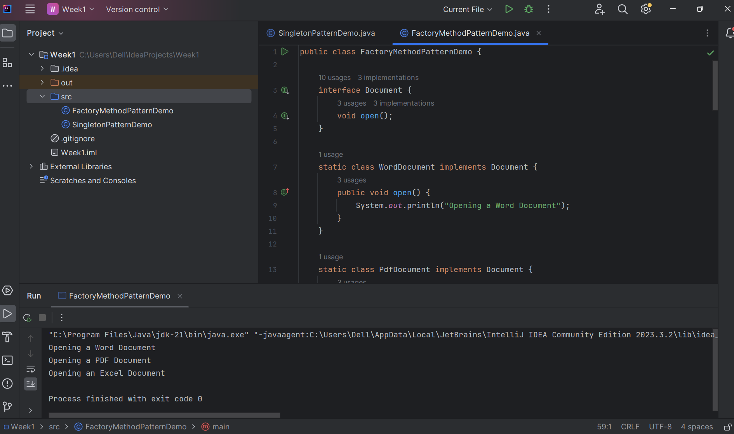

Exercise 7: Financial Forecasting

class Forecast {

static double predictRecursive(double initial, double rate, int years) {

if (years == 0)

return initial;

return *predictRecursive*(initial, rate, years - 1) \* (1 + rate);

}

static double predictIterative(double initial, double rate, int years) {

for (int i = 0; i < years; i++) {

initial \*= (1 + rate);

}

return initial;

}

}

public class FinancialForecasting {

public static void main(String[] args) {

double initialAmount = 10000;

double annualGrowthRate = 0.08;

int years = 5;

double futureValueRecursive = Forecast.*predictRecursive*(initialAmount, annualGrowthRate, years);

double futureValueIterative = Forecast.*predictIterative*(initialAmount, annualGrowthRate, years);

System.*out*.println("Future value using recursion: " + futureValueRecursive);

System.*out*.println("Future value using iteration: " + futureValueIterative);

}

}

OUTPUT

